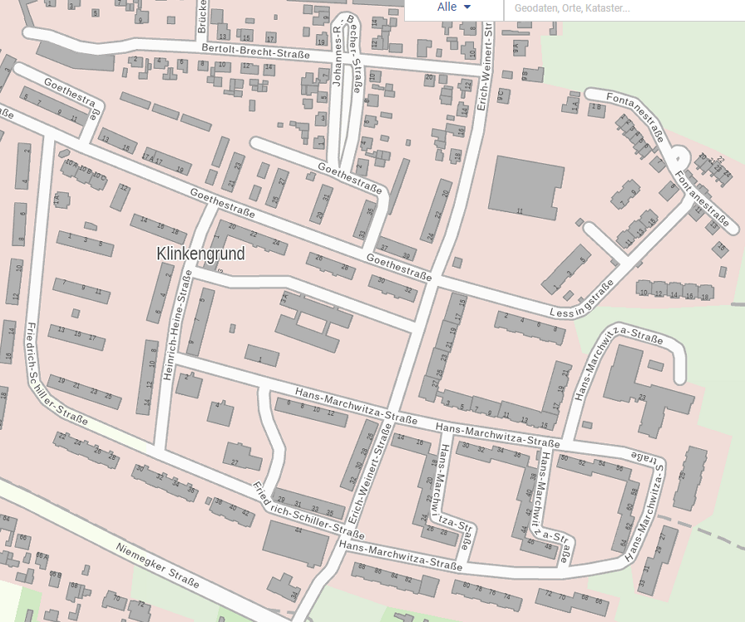
1.3
24.2
22
1.2
1.1
24.1
19
18
17
1
4
3
2
16

23
25
20
21
15
14
13

12

11
10
9
8
7
6
5

